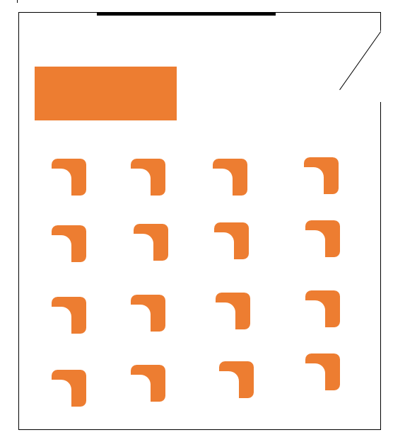
My Classroom

BEHAVIOR MANAGEMENT PLAN

Rules
- Be punctual when attending lectures, assessments and examinations
- Cooperate with the lecturer at all times
- Do not take foodstuffs in the classroom
- Treat each other with respect in the classroom. Bullying will not be tolerated
- Use of any electronic gadgets in the classroom is prohibited unless as instructed by the lecturer

Procedures
- Hand in your assignments before or on the deadline date. All submissions should be made after class or at the lecturer’s office.
- Before leaving the classroom after a lecture, sign against your name on the attendance sheet to confirm lecture attendance.
- If you wish to be excused, approach the lecturer quietly and politely explain why you need to be excused.

Consequences of breaking rules/mishandling procedures
- Arriving late for lectures will lead to expulsion from the said lecture. Students will not be allocated extra time in assessments and examinations after arriving late for the same.
- Taking of foodstuffs during lectures is a distraction to other students and therefore will lead to expulsion from the lecture
- Any form of violent behavior in the classroom will lead to serious disciplinary actions taken against the perpetrating students
- Use of electronic gadgets in the classroom when not instructed by the lecturer will lead to expulsion from the classroom
- A student who is expelled from a lecture is assumed to not have attended the lecture
- Late submission of assignments attracts a 5-mark penalty on the assignment score
- Attendance of less than 70% of lectures will lead to automatic failure of the unit

Reward System
- The best student overall during the semester will receive a free dinner at a five-star hotel, courtesy of the lecturer.
- Being active in class will also add a score to your final tally for the unit
- You will be awarded scores for attempting questions on assessments and exams.

Preferred Classroom design
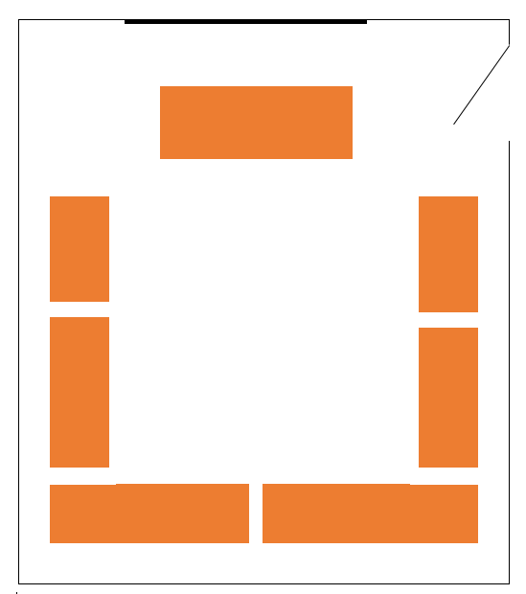
The arrangement above encourages student cooperation with the lecturer, making the entire classroom more proactive during lectures.
The classroom setup does not allow squeezing of many students into the classroom. This allows the lecturer to have maximum interaction with the students.
There is also less congestion in the classroom, making the students more comfortable during lectures.
It is easier for the lecturer to setup group discussions with the setup above, that will make the students be more active in the classes, promoting learning.

REFERENCES
Game, P. (n.d.). 20 Classroom Management Strategies and Techniques [+ Downloadable List]. Prodigy Education. https://www.prodigygame.com/main-en/blog/classroom-management-strategies/.
What is a Behavior Management Plan in the Classroom? Graduate Programs for Educators. (2020, October 30). https://www.graduateprogram.org/2020/01/what-is-a-behavior-management-plan-in-the-classroom/#:~:text=A%20behavior%20management%20plan%20is,is%20not%20synonymous%20with%20discipline.

